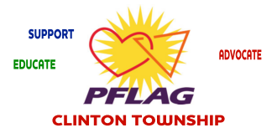

Hello,

PFLAG is the nation’s largest family and ally organization. Made up of parents, families, friends, and allies united with people who are lesbian, gay, bisexual, transgender, and queer/questioning.

PFLAG is committed to advancing equality and societal acceptance of LGBTQ people through its threefold mission of support, education and advocacy. PFLAG now has over 400 chapters and 200,000 members and supporters crossing multiple generations of American families in major urban centers, small cities and rural

Areas in all 50 states.

On behalf of the PFLAG Clinton Township Chapter we want to invite you to become a Chapter Member. Your annual support gives us the opportunity to connect with area schools in promoting safe schools, to participate in County networking Events, and to have monthly Chapter meetings providing support, education, and advocacy for the LGBTQ community.

At this time annual chapter dues are $35 (individual) or $55 (family). Please consider becoming a member for the coming year (2020-2021) by completing the attached form and mailing it to the address listed on the form.

We are here to stand on the forefront of change in the LGBTQ community and our hope

is to work together with our members to ensure a brighter tomorrow within our community and the community at large.

We hope you join us by becoming a member of PFLAG-CT. Thank you for your consideration.

Sincerely,

PFLAG-CT Board of Directors

We can be contacted @ [pflagct@gmail.com](mailto:pflagct@gmail.com)